◊ Shortly (re-)introduce your idea.

In this project I will build an application named Stint, a fun based movie archive pack with digital art and fringe interests.

It is implemented base on a similar project done for a book library that provides functions of a CRUD application on Python and Flask.

◊ Describe the progress you made since your prototype.

The project, at present, instead of just some non-functioning screens, has basic CRUD functions and decently layout movie screens. Data is stored in a local SQL Lite database and is now persistent across application restart. It accepts multiple users that can contribute to film reviews. A list of movies ranked by number of reviews is also created.

The database is initialized when none is present at application start up and populated with a few rows of sample records.

◊ Describe and discuss the challenges you encountered during the development process.

First, learning a computer language is not easier than learning a natural language. Creating and editing a project and read other’s code with it is like communicating to many people at higher levels in a natural language environment. I hit so many bumps and “climbed” many steep slopes to reach where I am now.

Selecting a web-based approach is a challenge in itself. There are too many things to go through before I can even start to work that includes understand the development and dependences of the solution that I choose and test out combination of program and tools and whether they work together. It is a trail and error process and much time was spent unproductive before a working combination was found.

Use Git and Github repository is a very good skill to learn but the vast functions and interfaces also pose a great challenge.

I love syntax highlighting because it makes reading code so much more comfortable. However, looking for an IDE that will do syntax highlighting, works with Github and Flask is such a task, I heard that Eclipse is good, but setting up Eclipse to have everything I need including a debugger is not easy. Some editors like Textmate, Sublime text or Atom do not integrate with Flask or Github, or are easy to organize. So, Visual studio is chosen for its seemingly simplicity.

Stint is separated into multiple views and templates, the standard practice of Flask app.

app folders are created

Inside those folders there is a file named __init__.py that creates the Flask instance and loads the app's view:

from flask import Flask

main = Flask(__name__)

import . . .

Bootstrap page templates views.py calls flask.render_template

Templates are located in the app's templates folder

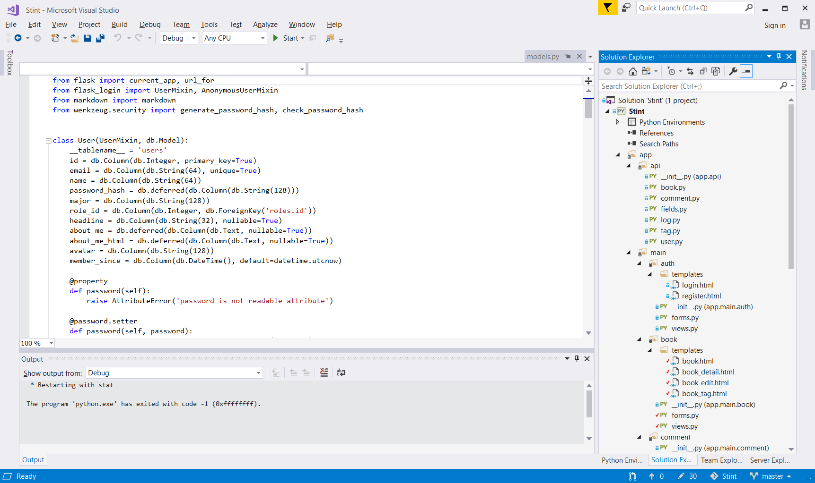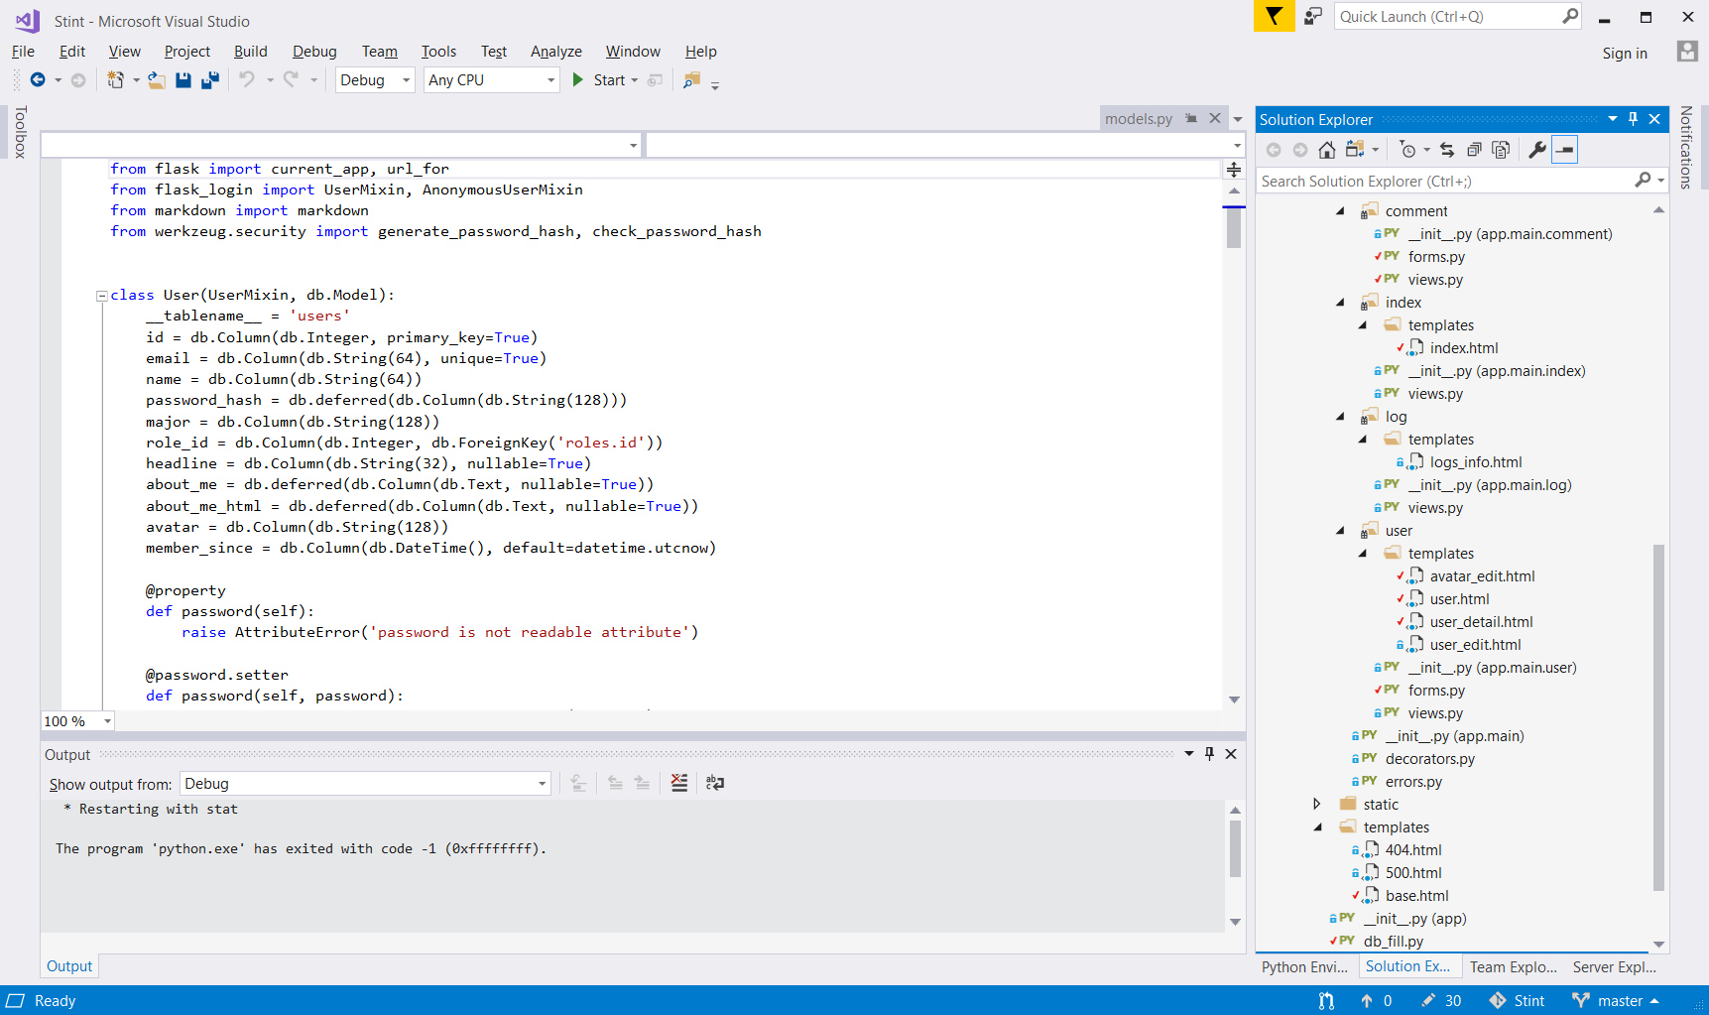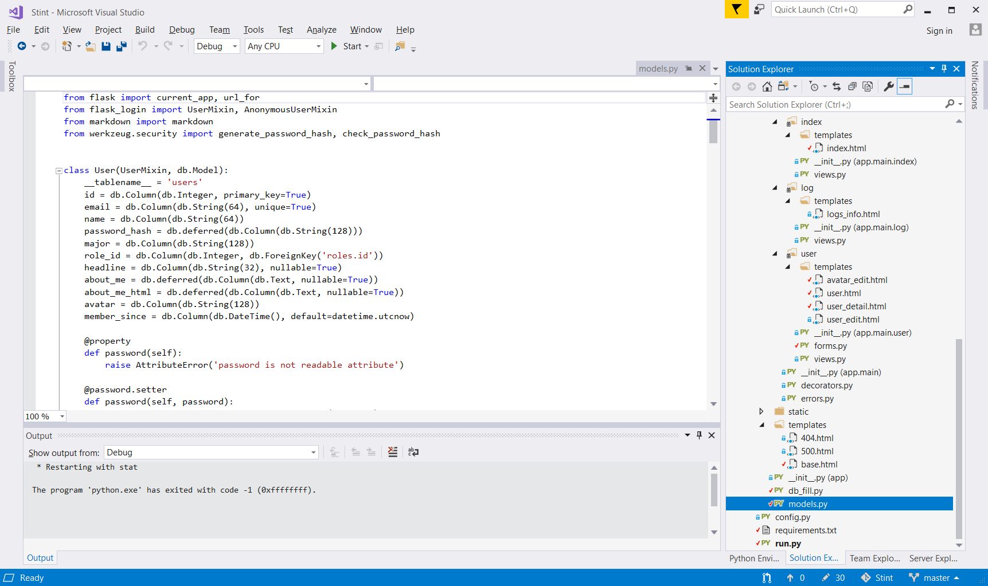

◊ Describe the decisions you took while developing your application and explain why you decided for a particular option against other possibilities.

◊ Describe and discuss specific problems.

◊ final reflection

a thought, idea, or opinion formed, or a remark made as a result of meditation